Challenge Number 990
Played on date: Jan. 12, 2019 Time: 14:00
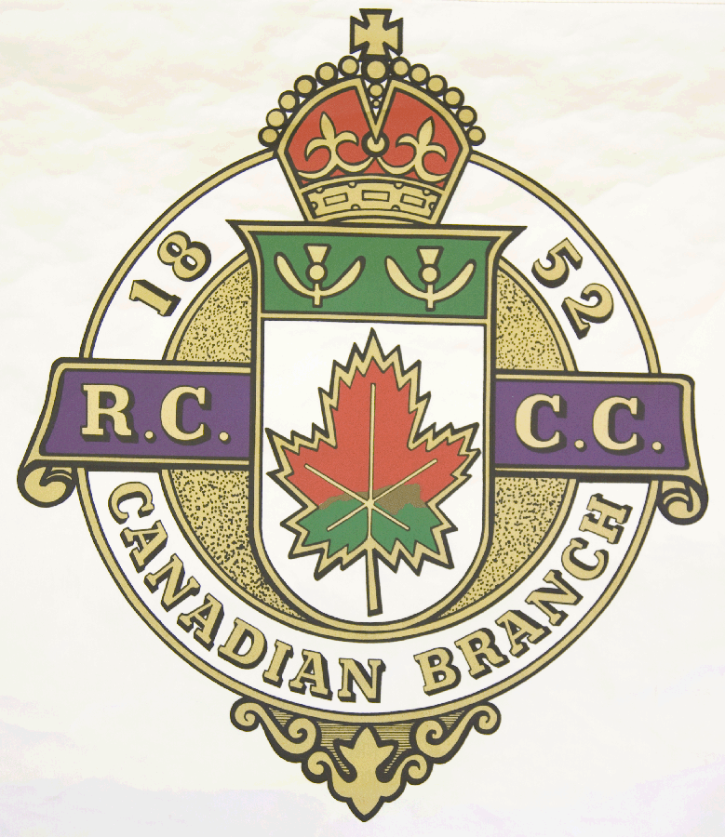
Hosting Club: Montreal Thistle (played at Lachine CC.)

Host Club Address: 4105 Fort Rolland

Host Club City: Lachine, Qc.

Host Club Telephone: 514-637-9521

Host Contact Person: Dave Ingham

Contact phone or email: 514-505-3250

Hosting Club: Thistle CC Challenging Club: Otterburn Legion CC

Skip: Kevin Ross Skip: Bruce Derry

Third: Jesse Ruppell Third: Marc Auclair

Second: Norm Dore . Second: Dean St. Pierre

Lead: Julie Hamel Lead: Jean Lanaisse

Skip: John Monroe Skip: Eric Green

Third: John Peters Third: Robert Derry

Second: Dave Ingham Second: Benoit Maluorni

Lead: Lead: Dan Monpetit

 | Skip | 1 | 2 | 3 | 4 | 5 | 6 | 7 | 8 | 9 | 10 | Score
Sheet  1 | Ross | 1 | 1 | 2 | 2 | 1 | 1 | 3 | 1 | 1 | 1 | 14
Sheet  1 | Derry |  |  |  |  |  |  |  |  |  |  | 0
Sheet  2 | Monroe | 1 |  |  | 1 |  | 4 |  | 0 |  | 1 | 7
Sheet  2 | Green |  | 2 | 3 |  | 1 |  | 2 | 0 | 1 |  | 9

Hosting club Score: __21______ Challenging club score: __9_______

Note: Description of the game should follow on separate page as well as photos of the teams.

